Corrosion of SiC and ZrC by Palladium with Applications to the Pebble Bed Modular Reactor

by

Michael P. Short

SUBMITTED TO THE DEPARTMENT OF NUCLEAR SCIENCE AND ENGINEERING IN PARTIAL FULFILLMENT OF THE REQUIREMENTS FOR THE DEGREE OF

BACHELOR OF SCIENCE IN NUCLEAR SCIENCE AND ENGINEERING AT THE
MASSACHUSETTS INSTITUTE OF TECHNOLOGY

MAY 2005

© 2005 Michael P. Short. All rights reserved.

The author hereby grants to MIT permission to reproduce and to distribute publicly paper and electronic copies of this thesis document in whole or in part.

Signature of Author:_____________________________________________
Michael Short
Department of Nuclear Engineering
May 18, 2005

Certified by:___________________________________________________
Ronald Ballinger
Professor of Nuclear Engineering & Materials Science
Thesis Supervisor

Accepted by:___________________________________________________
David G. Cory
Professor of Nuclear Science and Engineering
Chairman, Committee for Undergraduate Students

Corrosion of SiC and ZrC by Palladium with Applications to the Pebble Bed Modular Reactor

by

Michael P. Short

Submitted to the Department of Nuclear Science and Engineering on May 18, 2005
In partial Fulfillment of the Requirements for the Degree of
Bachelor of Science in Nuclear Science and Engineering

ABSTRACT

The effects of palladium on silicon carbide (SiC) and zirconium carbide (ZrC) were studied with applications to the Pebble Bed Modular Reactor. Samples of SiC and ZrC were sputter coated with palladium and heated for various times at various temperatures up to 1450K, a characteristic temperature for the PBMR. Upon examination of the samples by SEM microscopy, the SiC samples were observed to have been attacked by palladium, forming Pd2Si and forming channels along grain boundaries. These channels may allow other fission products to escape the kernels. However, palladium was not observed to attack ZrC, as no Pd-Zr phases were observed by X-Ray Diffraction and channels were not observed in the SEM. Instead palladium appeared to collect along grain boundaries and at triple points, suggesting diffusion is the method of Pd migration through ZrC.

Thesis Supervisor: Ronald Ballinger
Title: Professor of Nuclear Engineering and Materials Science

1 Introduction

Generation IV nuclear reactors are already showing promise for providing the next step in nuclear power generation. Concepts such as the High Temperature Gas-cooled Reactor (HTGR) and the Pebble Bed Modular Reactor (PBMR) provide many advantages over the current generation of water-cooled reactors. The use of an inert gaseous coolant allows for higher temperatures and less corrosion when compared to water. The modularity of the PBMR builds more redundancy and reliability into the system. However, with each technology that pushes the current boundaries of temperature, pressure and lifetime come new materials issues that must be identified and solved.

2 Background

2.1 PBMR Operation

A rough schematic of the PBMR is shown in Figure 1.1.
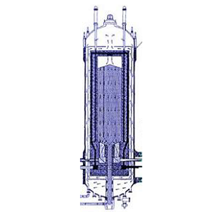
Figure 1.1 – PBMR Cross Section¹

In the figure the fuel pebbles, each six centimeters in diameter, occupy the cavity in the middle of the reactor, where they cycle through the reactor slowly. Upon exiting through the bottom they are tested for reactivity. Those pebbles that are still reactive enough are cycled back onto the top of the stack. Those that are not reactive enough are removed from the cycle for reprocessing. Helium is forced through the reactor at temperatures approaching 1500°K, allowing for a much higher efficiency when compared to lower temperature cycles. Using efficient compressors and turbomachinery allows this cycle to approach the theoretical Carnot efficiency, shown in Equation 1.1. As can be inferred from the equation, the higher the temperature on the hot side the higher efficiency can be achieved.

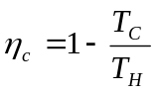 (1.1)

_{c} is the Carnot efficiency, and T_{H} & T_{C} are the hot and cold temperatures, respectively. An example of a PBMR taken from literature² shows reactor outlet temperature of 1173°K and an inlet temperature of 831°K. This would lead to a Carnot efficiency of 74.85%. The cited PBMR cycle efficiency is 47.3%, which is a large increase over today’s light water reactors with efficiencies ranging around 33%.

2.2 Pebble Composition

A cross section of a fuel pebble is shown in Figure 1.2.

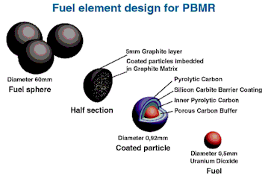
Figure 1.2 – PBMR Fuel Pebble Cross Section³

The outermost layer is made of graphite five millimeters thick, chosen for its ability to tolerate the high temperatures present in the PBMR. Inside each graphite sphere are about 110,000 fuel kernels, each less than a millimeter in diameter. On the inside is the actual UO₂ fuel, a sphere about half a millimeter in diameter. Immediately outside the UO₂ sphere is a layer of pyrolytic carbon, or very porous carbon. This is present to provide the fission gases created from fission product decay and uranium fission space to accumulate. This ensures that the pressure in the kernel does not reach a dangerous level. Outside the carbon layer is the silicon carbide (SiC) barrier, which theoretically functions as an impenetrable barrier to fission products. It is worth noting that while the helium outlet temperature may reach 1500°K the temperature of the kernels can be higher than that.

  - Fission Product Interaction with the SiC Barrier Layer

Studies have shown most of the fission products created in a uranium fission reactor to be chemically inert with SiC,^{4,5} specifically A.W. Searcy, and L. N. Finnie found that none of the six platinum metals, including palladium, is thermodynamically stable when reacting with silicon carbide.⁶ This means that none of these metals are expected to form stable phases with silicon, so no fission product attack is predicted from a thermodynamics standpoint. However, upon removal of test fuel spheres from reactors many kernels were found to have ruptured. Upon further investigation of the kernel cracks and the properties of SiC at high temperatures it was found that silver and palladium actually interact with the barrier layer. The actual method of attack had not yet been determined – corrosion, diffusion, formation of second phases, or a mix of these three could be responsible for the presence of fission products in the SiC barrier layer. This study will focus on palladium only.

It can be inferred from the Pd-Si phase diagram (shown in Appendix A) that Pd₂Si and PdSi are stable phases of palladium and silicon at temperatures predicted in the PBMR. While the melting point of palladium is above typical PBMR temperatures, alloys of palladium and silicon liquefy at these temperatures. Should any palladium interact with silicon in the SiC boundary layer it may create molten channels through which other fission products may escape. This behavior was observed by Minato et. al., where rhodium and ruthenium were observed at palladium attack sites in SiC-coated particles¹⁰.

  - ZrC as a Possible Replacement for SiC

As can be inferred from the phase diagram of palladium with silicon (shown in Appendix A), Pd-Si compounds are expected to form at temperatures present in the PBMR. Depending on the local concentration PdSi₂, PdSi and Pd₂Si could be expected to form at the palladium-SiC interface in the kernel. Upon formation it can also be inferred from the phase diagram that the Pd-Si phase will melt at relatively low temperatures of about 800°C. This melting of Pd-Si compounds creates channels that allow other fission products to escape, as any region of SiC attacked by palladium can be treated as a fission product channel. Studies have shown these channels to exist.⁷

Looking at the Pd-Zr diagram (Appendix A), however, one expects to find less interaction between palladium and zirconium, as its lowest eutectic phase has a higher melting point than that of the Pd-Si system, at 1030°C. S. Stolen and T. Matsui, as well as N. Selhaoui and J. C. Gachon have studied the Pd-Zr system in thermodynamic detail.^{8,9} Many possible Pd-Zr compounds might be expected to form, but at the high temperatures of the PBMR palladium will be expected to diffuse relatively rapidly, causing many Pd-Zr compounds to have a very low percent palladium. In this case the melting points of the Pd-Zr compounds increases rapidly from the eutectic melting point (1030°C) to that of pure zirconium (1855°C) from 75% atomic zirconium to 100%. For this reason ZrC may be expected to function as a better barrier than SiC.

Finally, looking at more phase diagrams of fission products (Ag, Cs…) with zirconium all show this very high melting point of high percent zirconium compounds. These diagrams all point to ZrC functioning as a better barrier than SiC, but again this study focused on palladium only.

  - Justification of This Study

While the helium in the PBMR removes most of the problems of corrosion from the reactor, enhancing the kernel barrier will effectively contain all possible corrosive fission products. This will allow the PBMR to actually reach its intended goal of a non-contaminated primary loop, boosting its expected safety performance to levels not yet reached by any operating reactor system. Carefully selecting the materials and justifying these choices may actually allow a reactor truly incapable of a meltdown or a radioactive release to be created. For if all the radioactive material in the reactor is safely contained in these ZrC barrier layers maintenance will become both easier and less frequent. This translates into large cost savings in the long run, for less kernels will have to be replaced over the lifetime of the reactor, and maintenance costs will also decrease.

Given that ZrC shows promise as an advanced barrier material, it is important to explore the interaction of Pd with ZrC as well as with SiC. This thesis presents the results of such an investigation.

3 Experimental Setup

  - Sample Preparation

Four 2” x 2” x ¼” chemical vapor deposited samples of silicon carbide (SiC) were obtained from Ultramet, cut into ½”x ½” square sections, then sent off to be polished. The samples were polished down to a roughness of less than 100nm, giving them a mirror finish. A cross section of a typical polished, unheated sample of SiC is shown in Figure 3.1a. Samples of CVD zirconium carbide (ZrC) on a graphite substrate were also obtained from Ultramet. These were 2” x 2” and only 250μm thick. Because a large degree of polishing may have eroded away the whole ZrC layer these were only lightly hand polished with 1200 grit sandpaper. A cross section of a typical ZrC sample is also shown in Figure 3.1b.

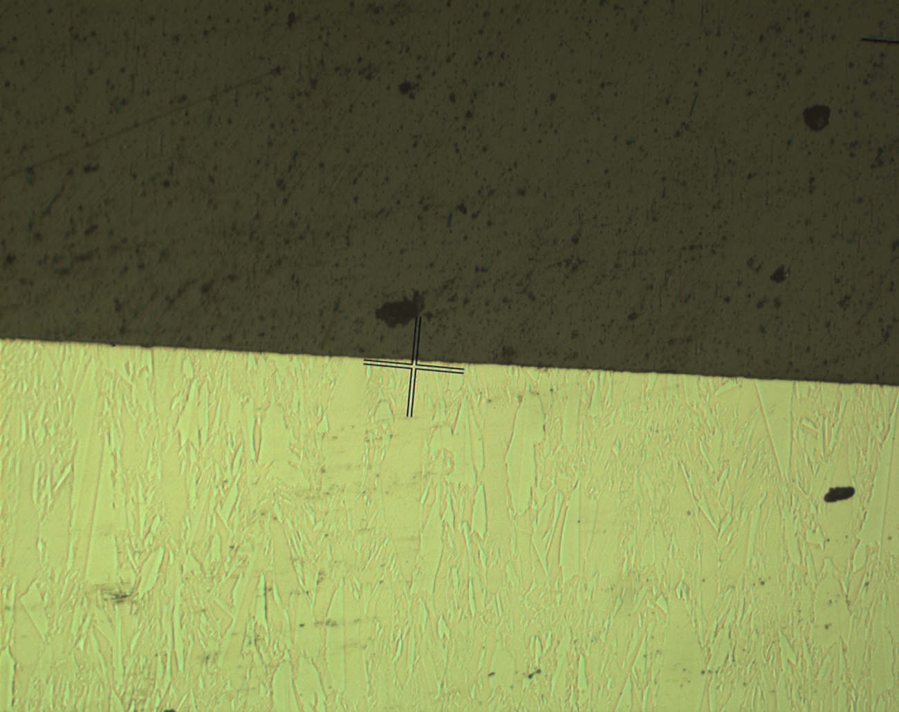
Figure 3.1a – Untreated SiC, 100x optical micrograph with high degree of grain relief. Note how grain growth is perpendicular to the sample face.
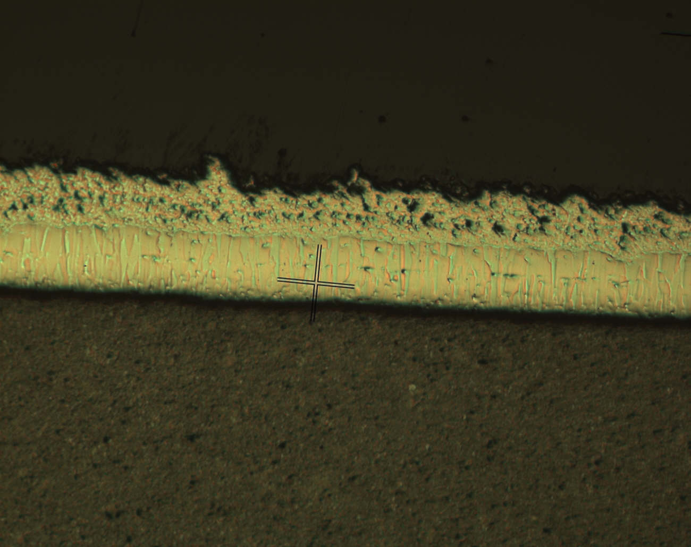
Figure 3.1b – Untreated ZrC, 100x optical micrograph with high degree of grain relief. Note the layered structure suggesting different growth stages, and also note the high degree of porosity in the upper layers.
Both samples were etched with Buehler diamond paper and Metadi colloidal silica compound to reveal grain structures. The SiC is obviously fully dense, while the ZrC appears to be partially porous. It also seems to have been grown in two steps, as evidenced by a sudden change in microstructure.

Samples were then coated in palladium by the following process. It became clear that simply placing Pd powder on the sample did not result in good contact, so samples were sputter coated. The process first involved cleaning. ZrC samples were washed in acetone, then in ethanol and allowed to air dry. SiC samples were first etched in 48% (by weight) hydrofluoric acid for twenty seconds in order to remove the SiO₂ oxidation layer. The samples were then washed in acetone, then ethanol. Finally all the samples were allowed to air dry.

Samples were wrapped in aluminum foil exposing only a ¼” x ¼” square on the top of the sample. This ensured that palladium was only deposited onto the top of the sample so that it would not migrate in from the side. The samples were sputter coated in a Polaron sputter coater at 2500kV using a palladium target and a partial vacuum of 0.001mmHg argon only. This ensured that the palladium coated the surface of the sample well. In order to keep the Polaron sputter coater alive samples were coated for 10 minutes, then kept under vacuum for 10 minutes to allow the sputter coater electronics to cool. The process was repeated twenty times per batch to ensure at least a 1μm coating of Pd on each sample. Optical micrographs of coated, unheated samples are shown in Figure 3.2.

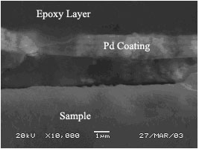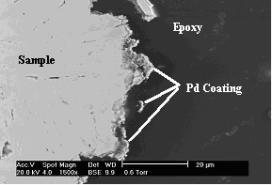
Figure 3.2a – SEM micrograph of Pd Figure 3.2b – SEM micrograph of Pd
coating on SiC unreacted sample coating on ZrC unreacted sample

In Figure 3.2a some separation of the Pd layer was observed, as in this micrograph. Samples were pressed lightly in order to try to avoid this. In Figure 3.2b the Pd coating is visible as a bright line across the sample edge in this backscatter image. Pd layer adhesion to the ZrC sample surfaces was excellent.

3.2 Sample Treatment

In order to simulate conditions in different sections of the PBMR and to determine the mechanism of Pd attack, samples were heated for different times and temperatures. Four temperatures were chosen: 1450°C, 1200°C, 1000°C and 800°C. Samples were heated in Lindberg furnaces. High temperature samples were heated in a ceramic open-vessel furnace with a constant flow of helium in order to prevent oxidation. Samples at a low enough temperature were heated in a quartz-tube vacuum furnace to further ensure no oxidation. As the vacuum furnace can provide up to 900°C, only samples at or below that temperature were heated in the vacuum furnace.

The temperature distribution across the samples was monitored to be constant to within 2°C. A Visual Basic program with National Instruments plugins was written in order to record and control up to 8 thermocouples of different types. Surface temperatures were monitored as well as the temperatures at all O-rings in order to ensure a proper seal. Thermocouples were also placed at the front and back of the samples, which amounts to a spacing of half an inch. Before heating began in the high temperature furnace helium began flowing over the samples for three hours, and continued throughout the duration of the run. The helium exited through a double bubbler to ensure that if helium flow stopped air would not be pulled in. Samples in the vacuum furnace were supported at the center, right near the middle thermocouple in the furnace. Periodic times and temperatures were hand recorded in addition to logging in the program to assure nothing went wrong.

Samples were heated to temperature at a rate of 25°C/min, kept at temperature for a specified amount of time, then cooled down at a rate of 10°C/min. All samples were heated individually. Below is a table of sample times and temperatures.

Table 3.1 – Heating times, temperatures, and analyses of samples in this study
Sample | Time (hr) | Temp (°C) | Analyses | Notes
S01 | 100 | 1450 | Optical, SEM, EDX
S02 | 100 | 1450 | XRD | XRD showed small peaks
S03 | 100 | 1200 | Optical, SEM, EDX, XRD
S04 | 50 | 1200 | SEM, XRD
S05 | 100 | 1000 | SEM, XRD
S06 | 200 | 800 | SEM, XRD
S07 | --- | --- | SEM
Z01 | 100 | 1450 | Optical, SEM, EDX | Pd penetrated entire sample
Z02 | 100 | 1450 | XRD | Overoxidized, destroyed
Z03 | 10 | 1450 | Optical, SEM, EDX
Z04 | 100 | 1200 | --- | Overoxidized, destroyed
Z05 | --- | --- | Optical, SEM | Pd coating test
Z06 | --- | --- | Optical, SEM | Control (Uncoated)
Z07 | 50 | 1200 | SEM, XRD
Z08 | 100 | 1000 | SEM, XRD
Z09 | 200 | 800 | SEM
Z10 | 5 | 1200 | SEM
S samples denote SiC and Z samples denote ZrC. After the furnaces cooled down samples were removed and inspected. No further heating or chemical processes were done to the samples from this point on.

Each sample was cut in half with a Buehler low speed diamond saw using distilled water as a lubricant. Half of each sample was used for analysis and half of each sample was stored for any later use. Each sample half was cut in half again – this created a piece for destructive testing (polishing & etching) and a piece for non-destructive testing.

  - Sample Preparation for Analysis

Samples were prepared for analysis in a Scanning Electron Microscope (SEM) equipped with EDX and for analysis using an X-Ray Diffractometer (XRD). XRD-bound samples were simply mounted in an XRD sample stage and saved for analysis, after observation in an optical microscope. These samples were mounted so the face with the palladium reaction would face the x-ray source.

Samples bound for the SEM were mounted in Buehler Epoxymet epoxy with a plastic 1” sample ring and allowed to cure overnight. Some of the samples had alumina powder added to the epoxy mix in order to increase the hardness of the epoxy. Previous experiments had shown poor edge retention when dealing with SiC samples without an epoxy hardener.

Mounted samples were then polished to a mirror finish. First samples were sanded with 120 grit SiC sandpaper to expose the whole face. Upon surface exposure the samples were polished for five minutes each at 5lb/sample with the following grit SiC sandpapers: 180, 240, 320, 600, 1200. If a polishing step failed to remove the scratches from the previous step it was repeated. After SiC sandpaper the samples were polished with Allied diamond lapping films, as previous work showed these to have the best edge retention. The following sized diamonds were used in this study for two minutes each at 7lb/sample: 30μm, 15μm, 9μm, 6μm, 3μm, 1μm. Finally samples were given a final polish and etching with a Buehler 0.05μm colloidal silica suspension for 5 minutes at 7lb/sample. This provided a high degree of grain relief, making grains and other sample features far easier to distinguish.

Following inspection in the optical microscope some samples’ images were recorded. All samples were given a 150Å carbon coating and sent to the SEM.

  - Sample Analysis

Samples were analyzed in a JEOL JSM-5910 electron microscope equipped with a secondary electron detector and an EDX system, and a Phillips XL-30 environmental SEM equipped with a backscatter detector and an EDX system. Numerous images were acquired at a variety of accelerating voltages, EDX spectra were taken of interesting features, and elemental maps were taken of some samples in order to determine relative palladium penetration. Point spectra were taken for between 30 seconds and 5 minutes, while all elemental maps were taken for at least 10 minutes.

The other half of each sample was analyzed in a Rigaku 185mm Bragg Brettano X-Ray Diffractometer in θ-2θ mode. Quick scans were performed to get a rough impression of the phases in the sample, then 30 minute scans were performed on each sample analyzed by XRD.

Data & Results

In this section the data and results are presented. First optical micrographs are shown, then SEM images, and finally XRD scan data are shown to illustrate the phases present.

  - Silicon Carbide Samples

The silicon carbide samples as a whole showed clear attack by palladium. Non-uniform interaction layers were observed, and the presence of attack nodes was also observed in accordance with previous literature. These new data suggest that the nodes form at grain boundaries on the surface of the sample.

4.1.1 Optical Microscopy

Even in an optical microscope the SiC samples showed evidence of palladium attack. Below are images taken at 500x magnification.

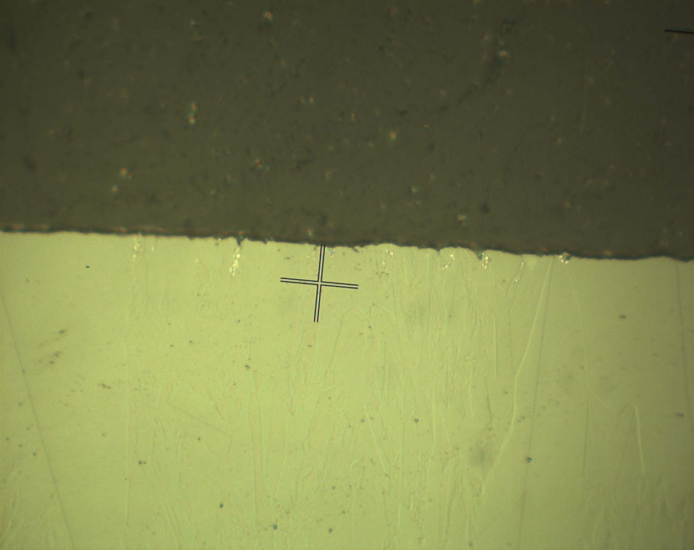
Figure 4.1a – 500x optical image of S01. Observe the appearance of white spots (palladium) near small channels at the sample surface.
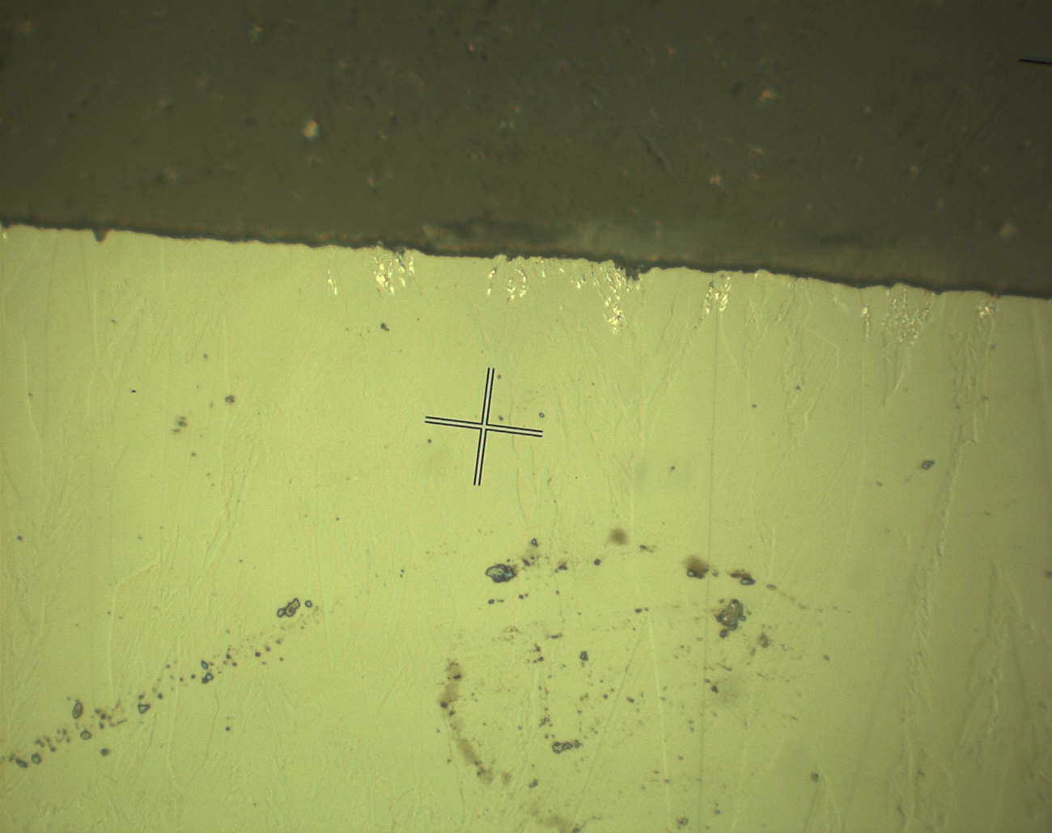
Figure 4.1b – 500x optical micrograph of S01. Note the pitting of the sample surface combined with the presence of palladium (white regions) near those channels

Figure 4.1c – 200x optical micrograph of S06. Note grain growth perpendicular to the sample face.
4.1.2 Scanning Electron Microscopy and EDX Elemental Maps

Representative SEM images of each sample are now presented.

S01 SEM Images

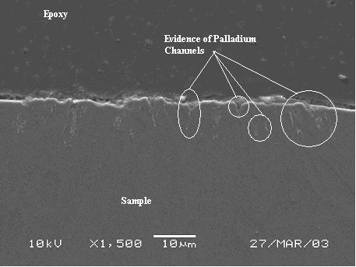
Figure 4.2a – 1500x SEM image of S01 with numerous palladium attack sites visible
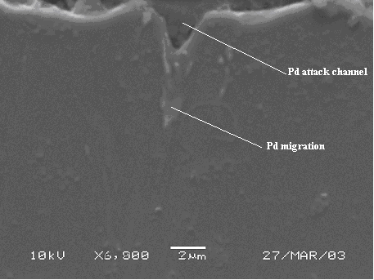
Figure 4.2b – 6000x SEM image of S01, with focus on one palladium attack site

S01 EDX Elemental Map

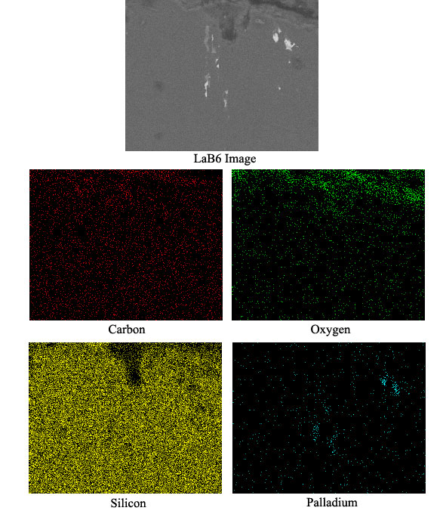
Figure 4.2c – EDX elemental map of S01. Note the migration of the palladium (white areas) through the sample, as evidenced by the palladium EDX map.

S03 SEM Images

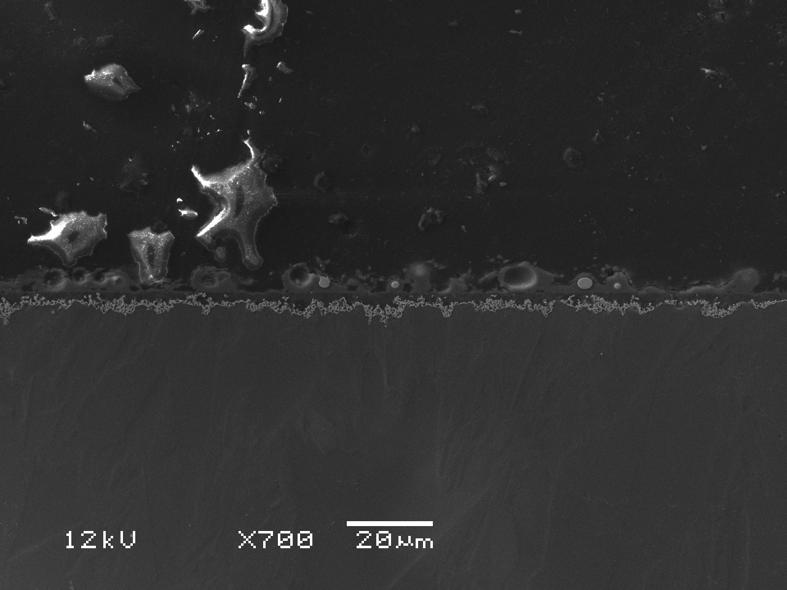
Figure 4.3a – 700x SEM image of S03 showing an interaction layer of Pd and SiC on the surface of the sample. Note the non-uniformity of the Pd attack.
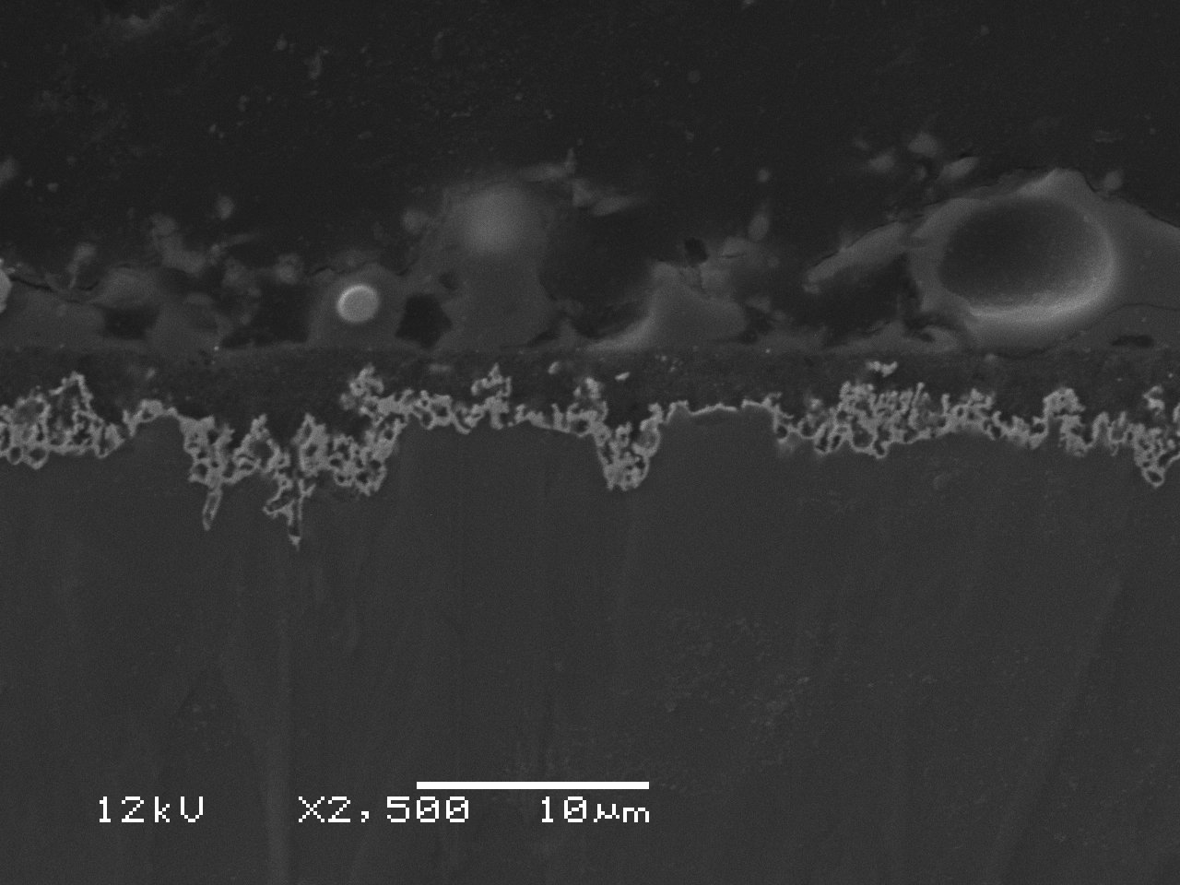
Figure 4.3b – 2500x SEM image of S03 showing Pd attack nodes. The four nodes in this image appear to be located on grain boundaries.

S04 SEM Images

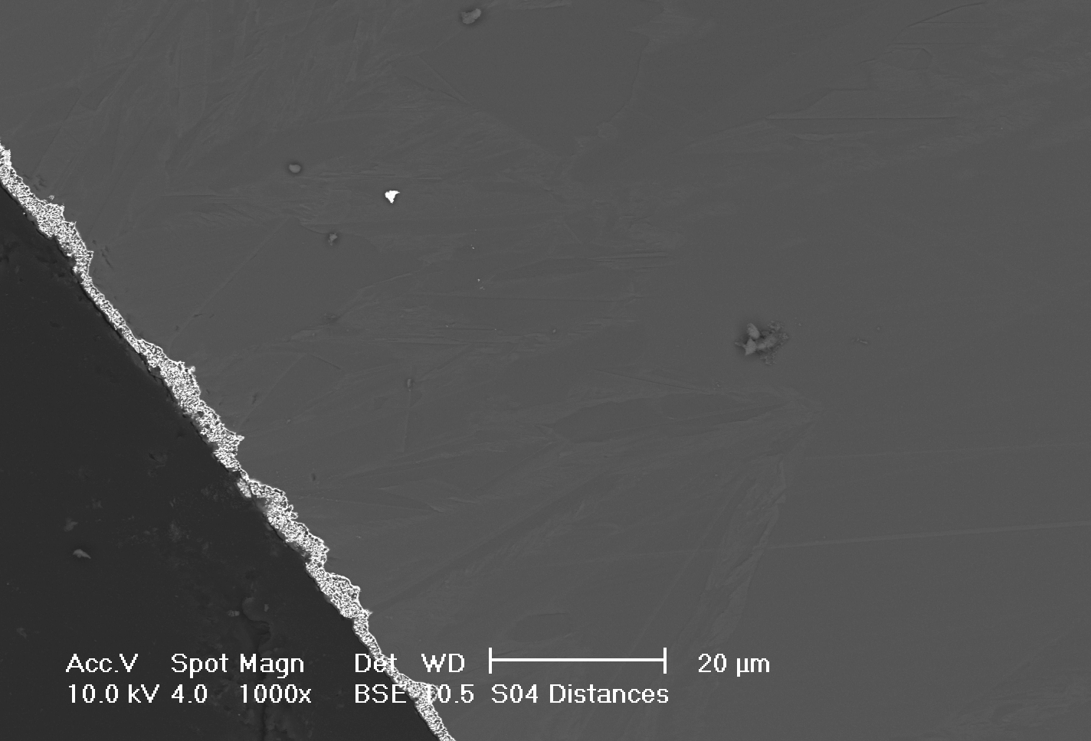
Figure 4.4a – 1000x SEM image of S04 showing a clear interaction layer on the sample surface. Note how attack is deeper at grain boundaries.
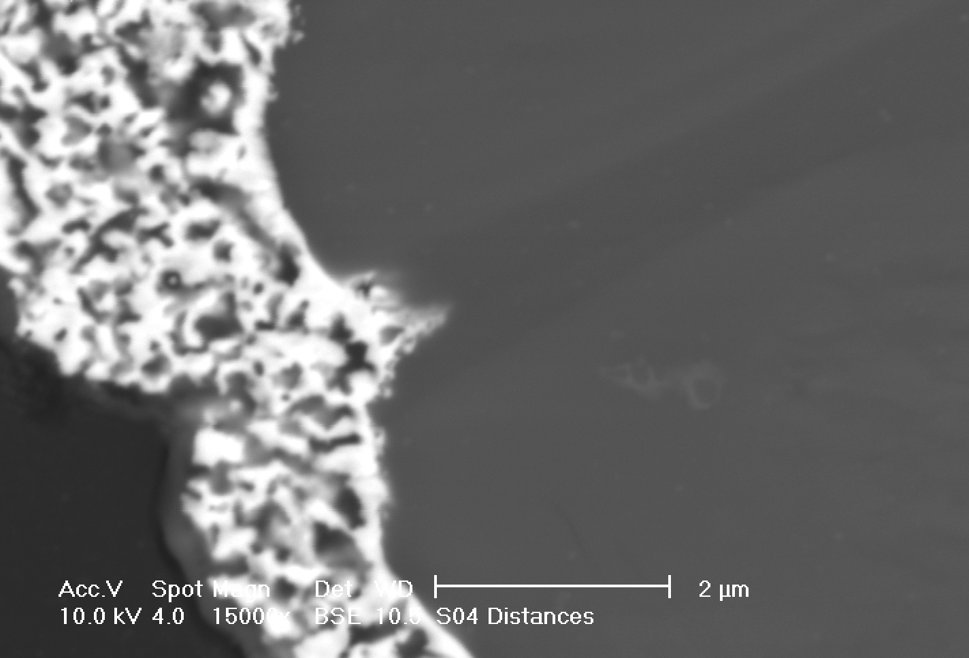
Figure 4.4b – 15000x SEM image of S04 showing preferential attack of palladium for a grain boundary in the sample.

S04 EDX Elemental Map

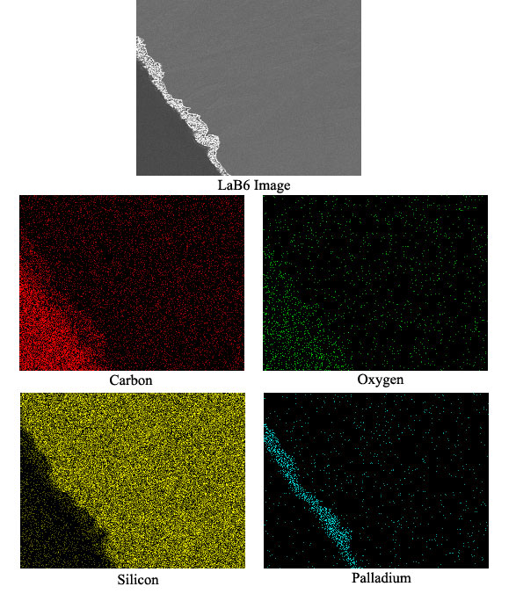
Figure 4.4c – EDX elemental map of S04 showing the interaction layer on the surface of the sample. This is evidenced by the appearance of palladium in silicon poor regions of the sample, and a higher presence of free carbon.

S05 SEM Images

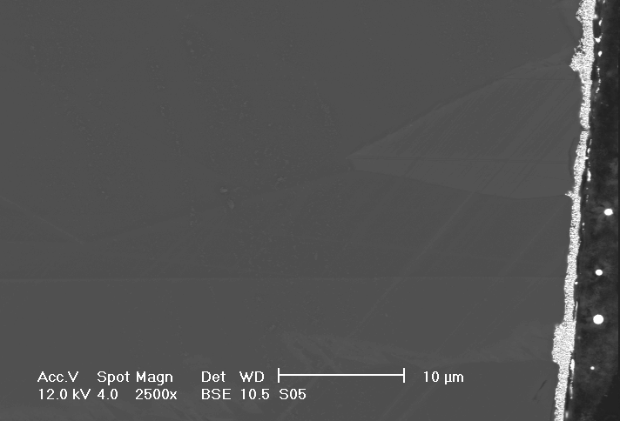
Figure 4.5a – 2500x SEM image of S05 showing three Pd attack nodes clearly located on grain boundaries.
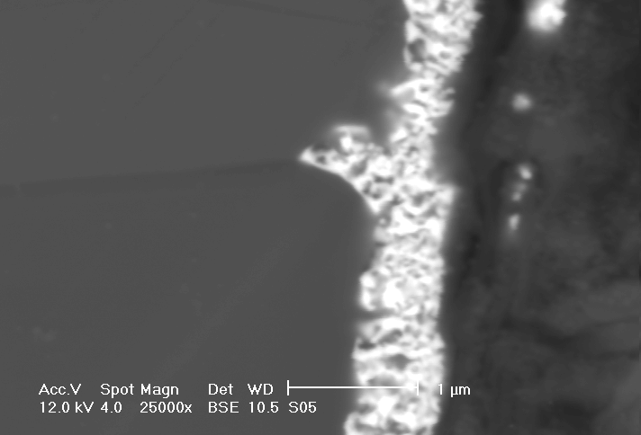
Figure 4.5b – 25000x SEM image of S05 showing a close-up of one attack node. The attack region is clearly progressing faster on grain boundaries than through bulk grains.

S06 SEM Images

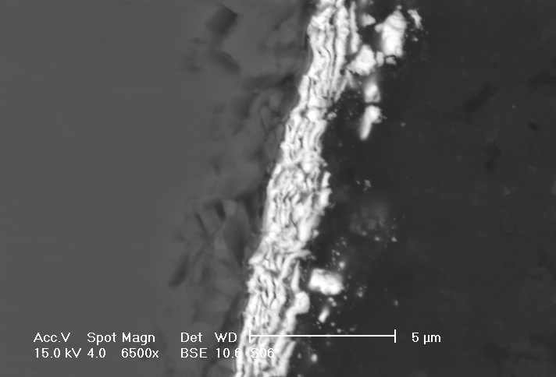
Figure 4.6a – 6500x SEM image of S06 showing little attack
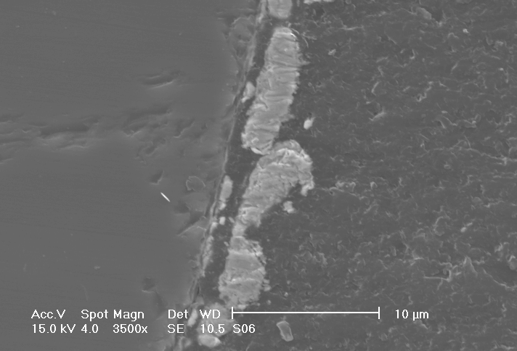
Figure 4.6b – 3500x SEM image of S06 showing very little attack of the sample surface

S07 SEM Images

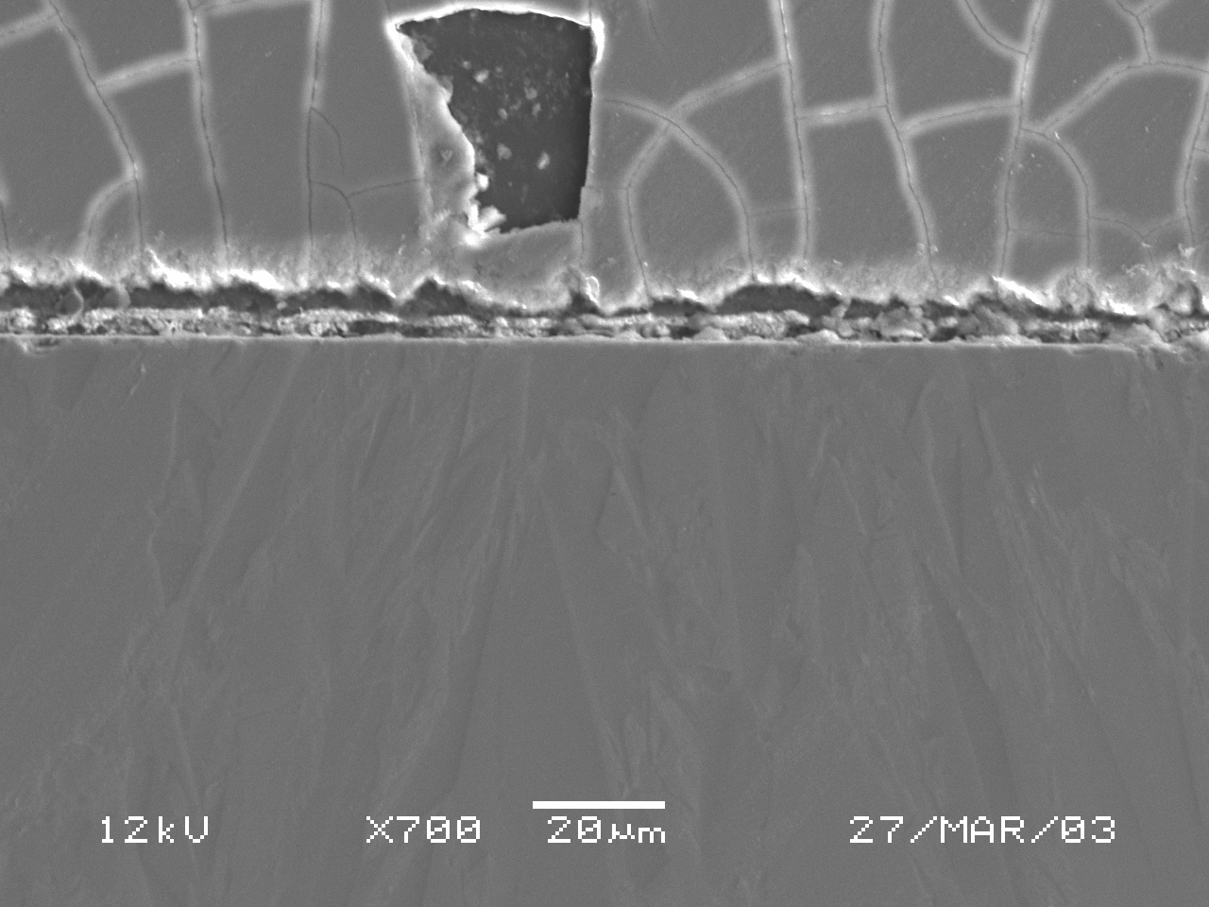
Figure 4.7a – 700x SEM image of S07. Note the grain morphology of the sample. The cracked region above the palladium layer is dried etchant.
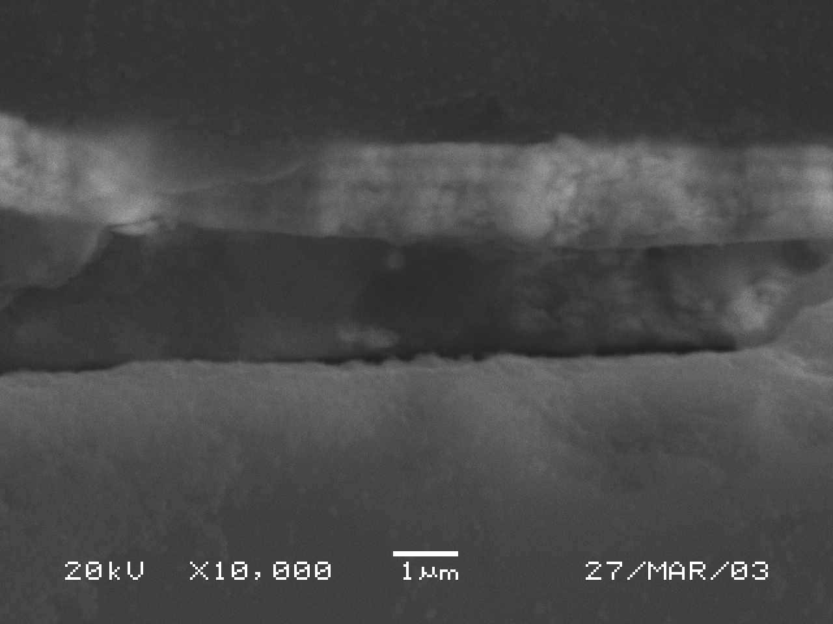
Figure 4.7b – 10000x SEM image of S07 showing the thickness of the palladium layer

    - X-Ray Diffraction Data

Sections from XRD scans are now presented, with lines marked out for key phases. Note the existence of Pd₂Si in most of the scans. The labels for the peaks always tell the phase and intensity, and sometimes the orientation of that peak. For example, in Figure 4.8a the line which reads “Pd2Si, 100.0% (111)” means that that is a Pd₂Si peak with the highest intensity corresponding to the (111) plane. Percents are in comparison to the highest peak’s intensity.

XRD of S02

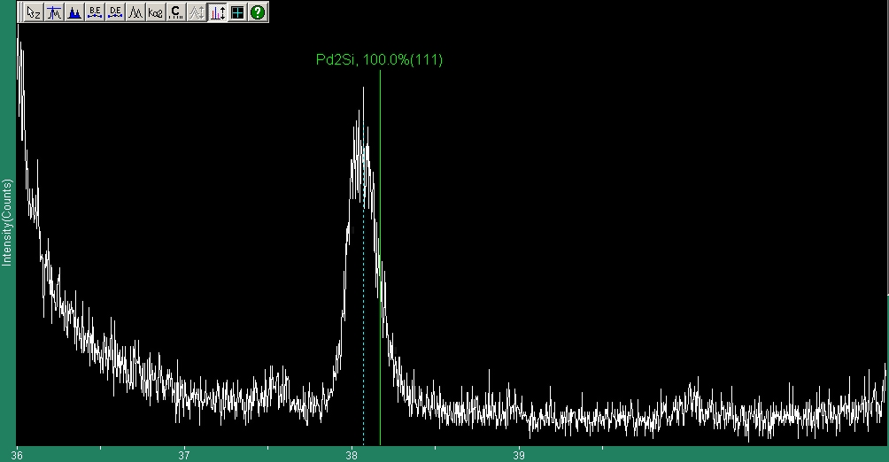
Figure 4.8a – XRD scan of S02 showing existence of Pd₂Si
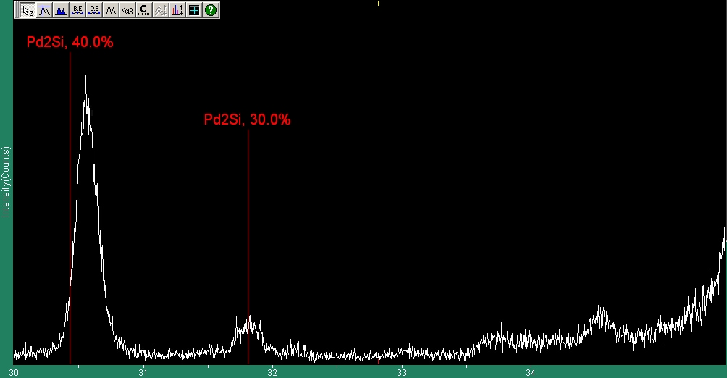
Figure 4.8b – XRD scan of S02 showing possible existence of Pd₂Si

XRD of S03

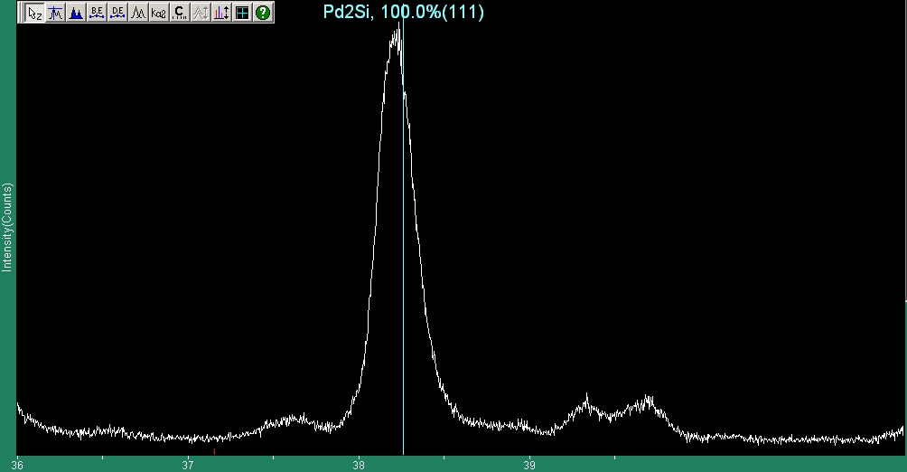
Figure 4.9a – XRD scan of S03 showing existence of Pd₂Si
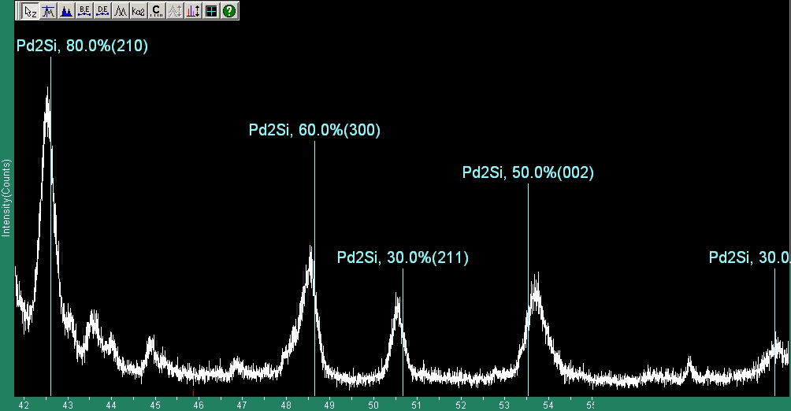
Figure 4.9b – XRD scan of S03 showing clear existence of Pd₂Si

XRD of S04

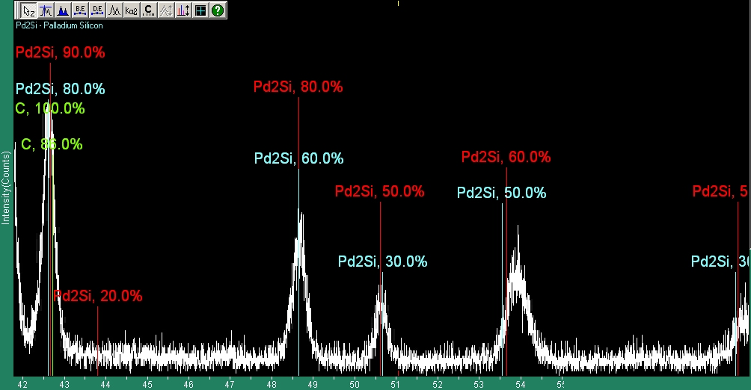
Figure 4.10a – XRD scan of S04 showing existence of Pd₂Si
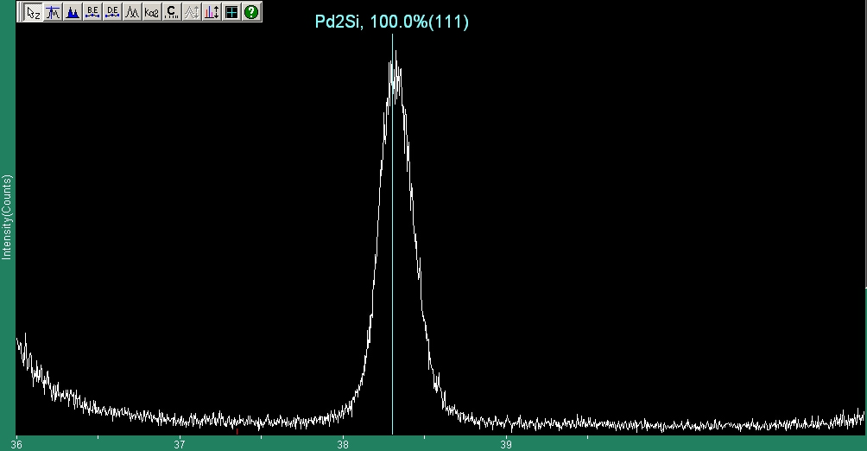
Figure 4.10b – XRD scan of S04 showing existence of Pd₂Si
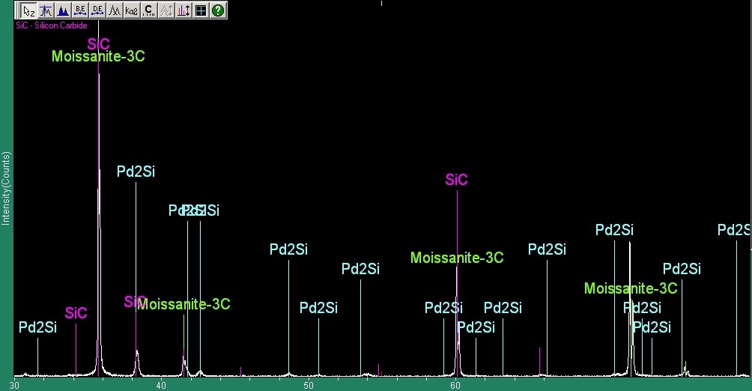
Figure 4.10c – Zoomed out XRD scan of S04 showing existence of Pd₂Si. Note the very low intensity of the Pd₂Si peaks showing that not much is present. However since so many locations match it is considered a positive identification. Moissanite-3C is silicon carbide.
XRD of S05

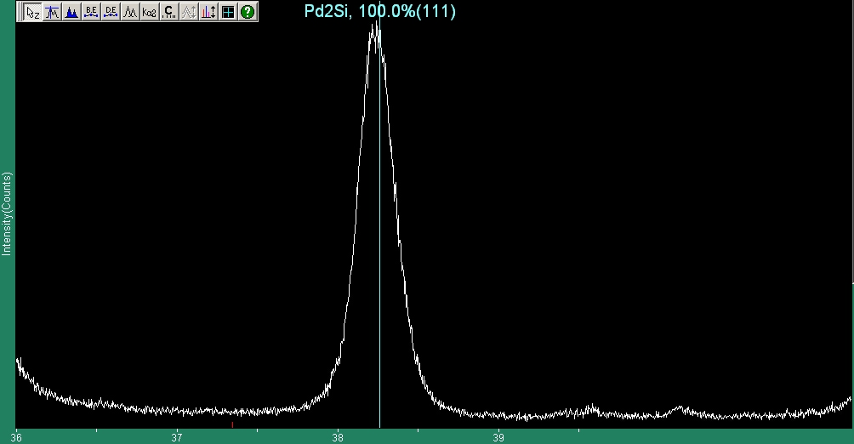
Figure 4.11a – XRD scan of S05 showing existence of Pd₂Si
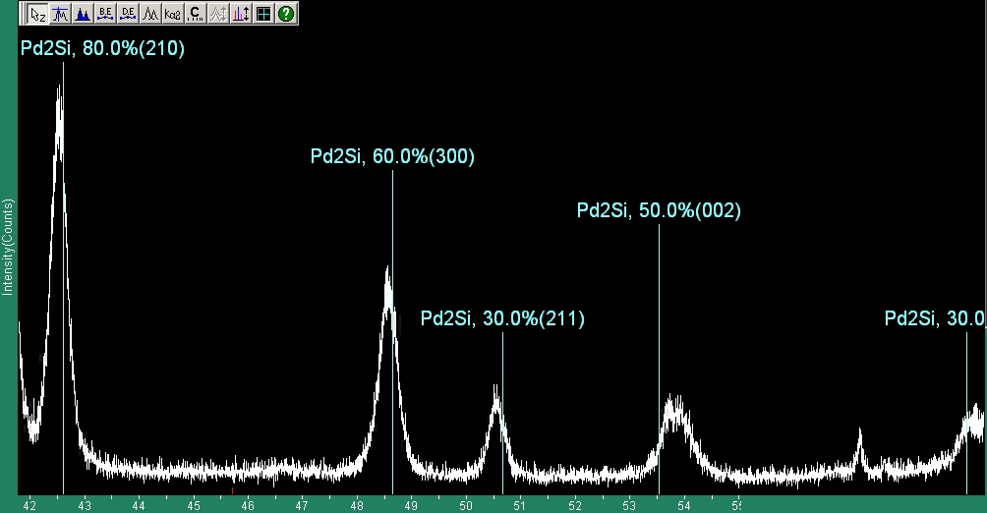
Figure 4.11b – XRD scan of S05 showing existence of Pd₂Si
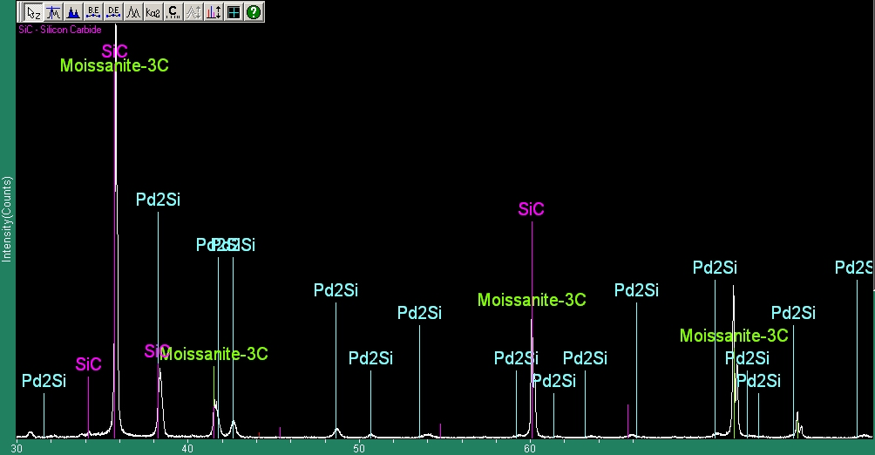
Figure 4.11c – Zoomed out XRD scan of S05 showing existence of Pd₂Si. Again Moissanite-3C is silicon carbide.

XRD of S06

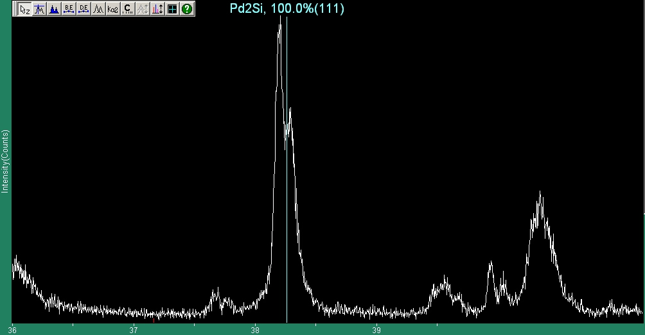
Figure 4.12a – XRD scan of S06 showing existence of Pd₂Si
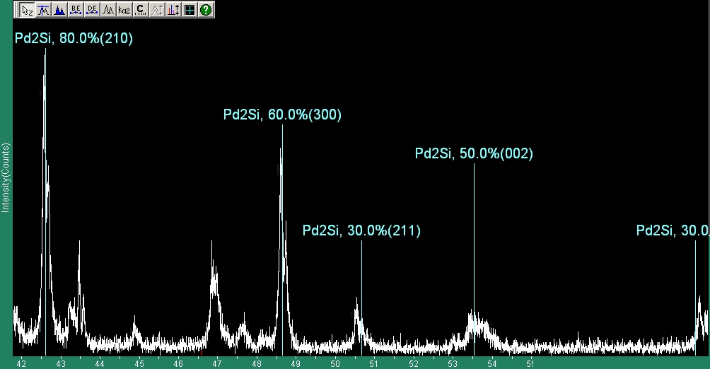
Figure 4.12b – XRD scan of S06 showing existence of Pd₂Si
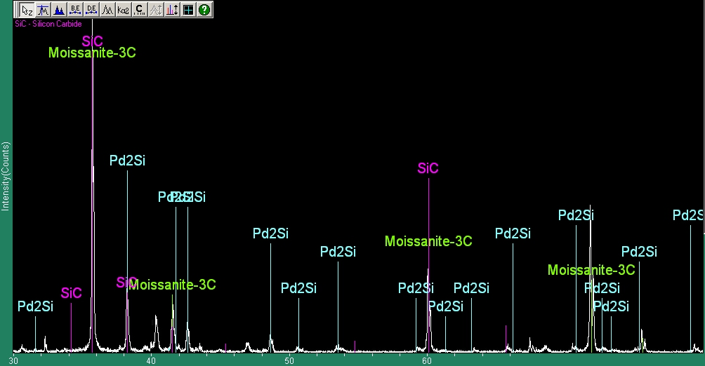
Figure 4.12c – Zoomed out XRD scan of S06 showing existence of Pd₂Si
  - Zirconium Carbide Samples

No optical images of the ZrC were kept due to the inability to distinguish palladium-related features on the samples. However, SEM micrographs showed palladium presence under the surface of the sample, suggesting some kind of migration. XRD scans showed no conclusive Pd-Zr phases, suggesting that diffusion was the method of migration. Furthermore palladium was only observed on grain boundaries or at triple points, suggesting grain boundary diffusion as the mechanism for Pd migration in ZrC.

    - Scanning Microscopy Images and EDX Elemental Maps

Z01 SEM Images

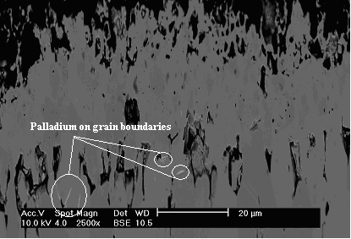
Figure 4.13a – 2500x SEM image of Z01 showing Pd on grain boundaries. Note the high degree of sample porosity
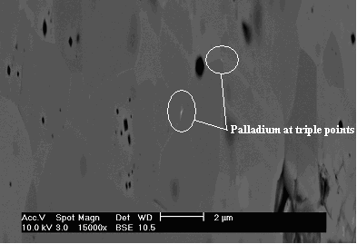
Figure 4.13b – 15000x SEM image of Z01 showing Pd on grain boundaries. Again note the high porosity.

Z01 EDX Elemental Map

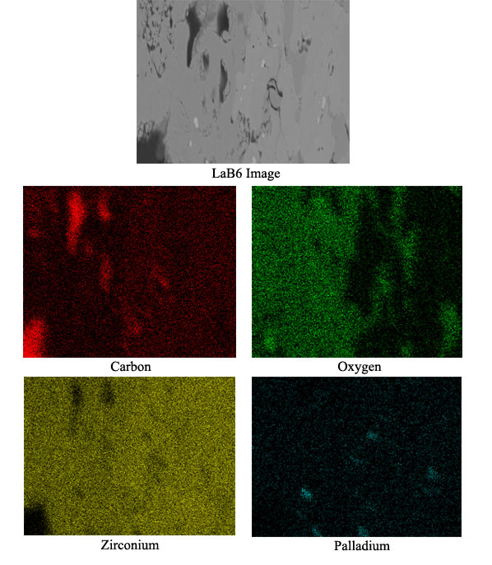
Figure 4.13c – EDX elemental map of Z01 showing existence of palladium at grain boundary triple points

Z03 SEM Images

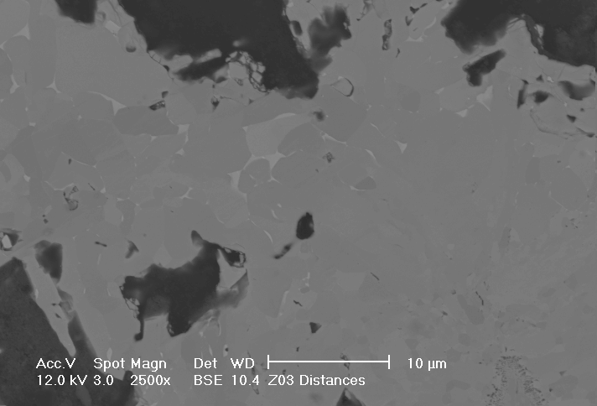
Figure 4.14a – 2500x SEM image of Z03 showing large quantities of palladium on grain boundaries and triple points
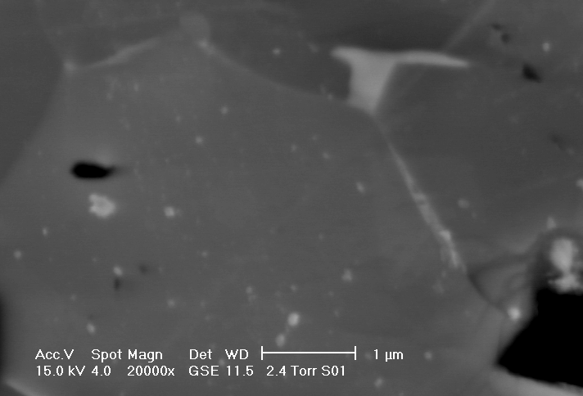
Figure 4.14b – 20000x SEM image of Z03 showing Pd on grain boundaries. The “2.4 Torr S01” label on the image is a mislabel – it should read “Z03 Distances.”

Z05 SEM Images

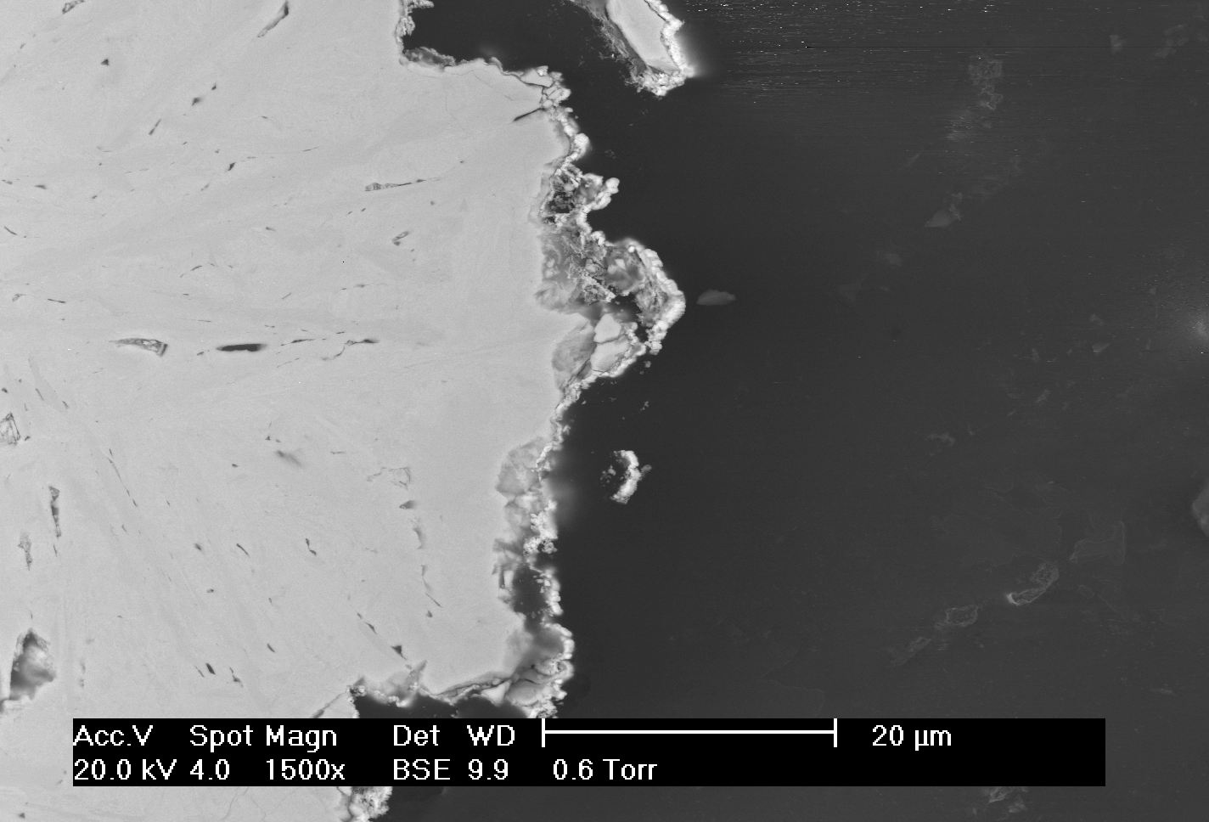
Figure 4.15 – 1500x SEM image of Z05 with relatively little interaction

Z06 SEM Images

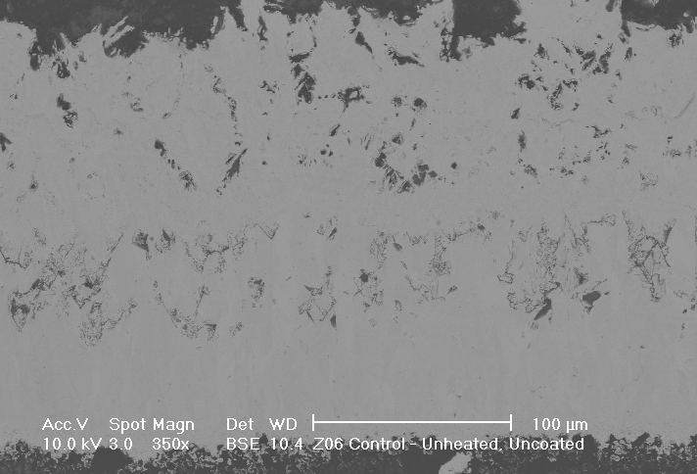
Figure 4.16 – 1500x SEM image of Z06. Note the layered structure of the ZrC sample

Z07 SEM Images

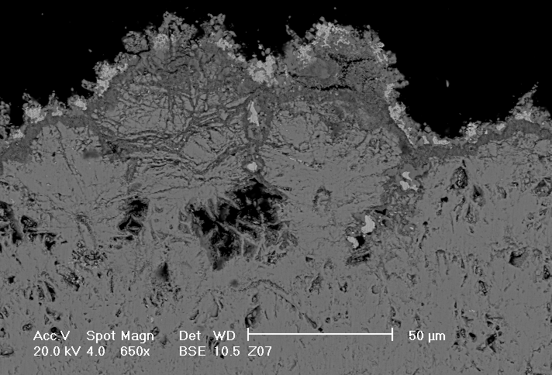
Figure 4.17a – 650x SEM image of Z07 suggesting diffusion of palladium through the pores of the sample

Z07 EDX Elemental Map

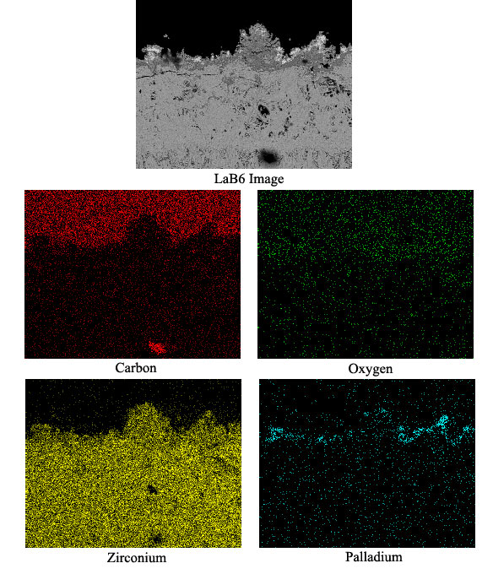
Figure 4.17b – EDX elemental map of Z07 showing palladium on the sample surface
Z08 SEM Images

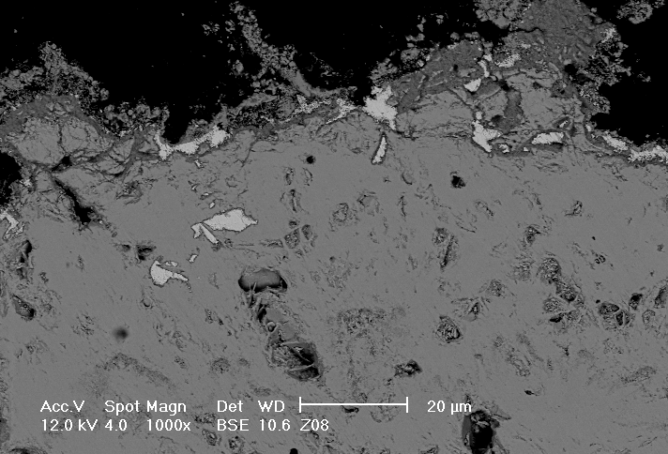
Figure 4.18 – 1000x SEM image of Z08 showing palladium in the sample pores

Z09 SEM Images

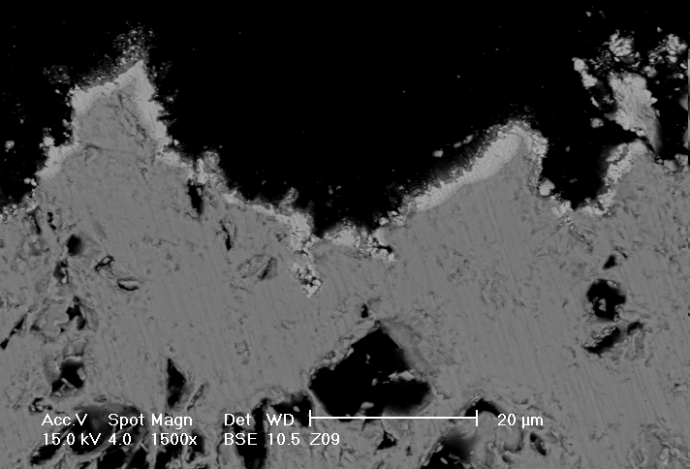
Figure 4.19 – 1500x SEM image of Z09 showing very little migration at all

Z10 SEM Images

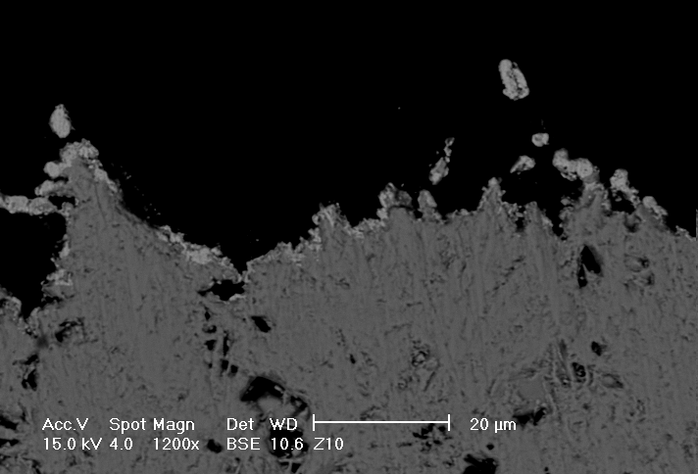
Figure 4.20 – 1200x SEM image of Z10 showing little to no palladium migration

    - ZrC X-Ray Diffraction Data

XRD of Z02

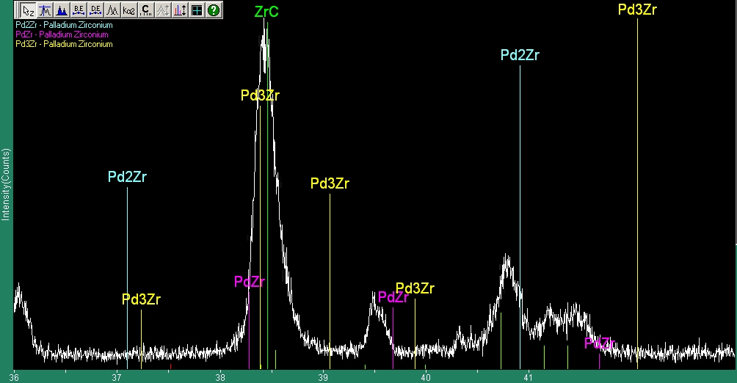
Figure 4.21a – XRD scan of Z02 showing ZrC, but no conclusive Pd-Zr phases

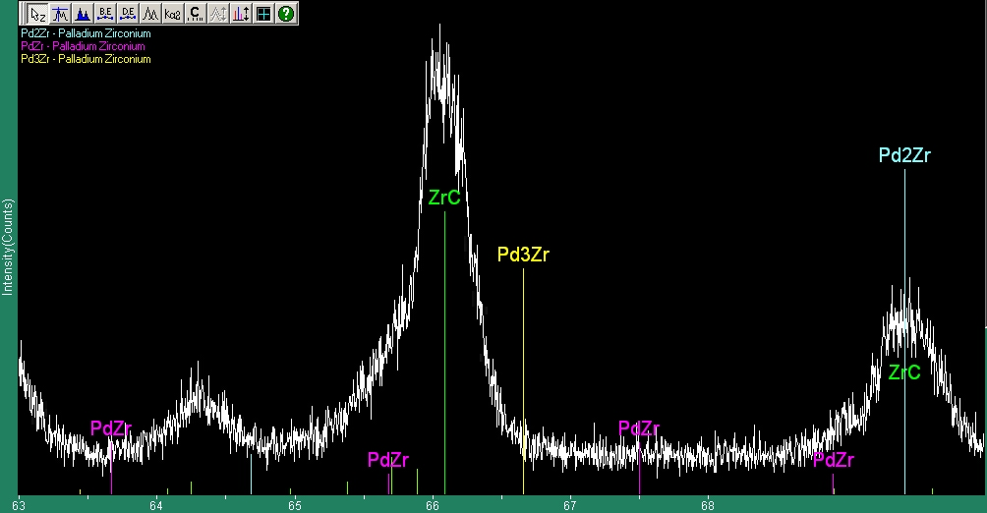
Figure 4.21b – XRD scan of Z02 showing ZrC, but no conclusive Pd-Zr phases
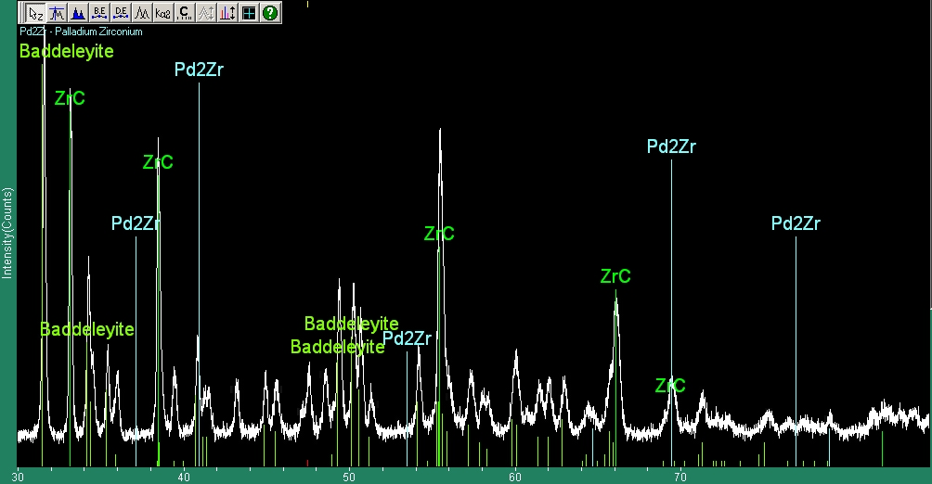
Figure 4.21c – XRD scan of Z02 showing ZrC, but no conclusive Pd-Zr phases. Baddeleyite is zirconium oxide.

XRD of Z07

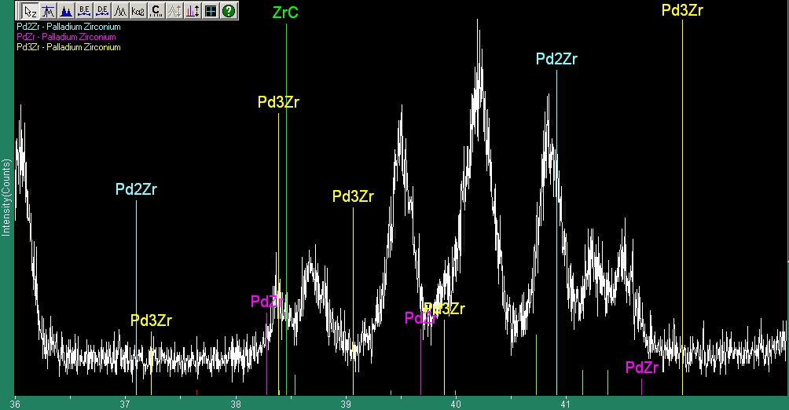
Figure 4.22a – XRD scan of Z07 showing ZrC, but no conclusive Pd-Zr phases
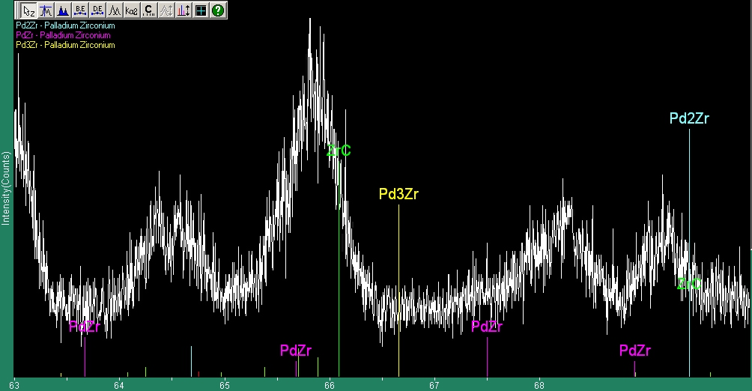
Figure 4.22b – XRD scan of Z07 showing ZrC, but no conclusive Pd-Zr phases

XRD of Z08

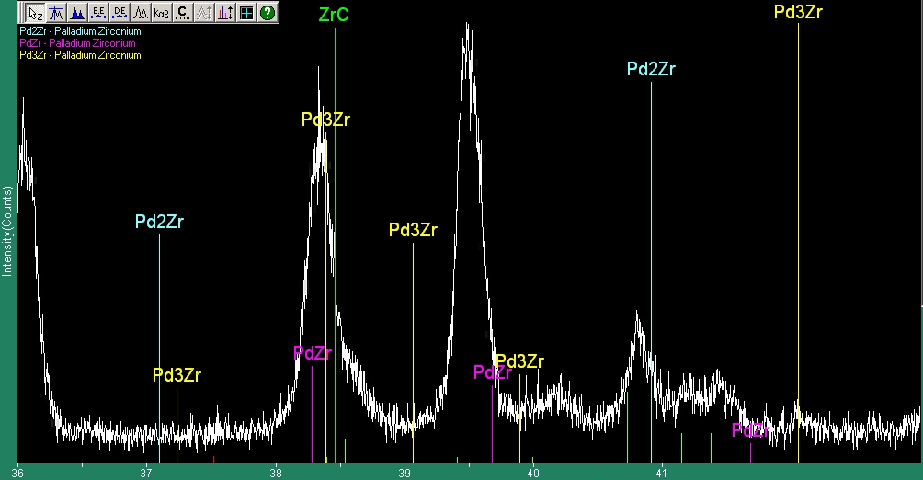
Figure 4.23 – XRD scan of Z08 showing ZrC, but no conclusive Pd-Zr phases

5 Analysis & Discussion

An analysis of each sample will now be presented, with explanations of the phenomena observed in the data.

5.1 Silicon Carbide Samples

S01 – Palladium attack was quite apparent in this sample, with an average penetration depth of 15μm. In the SEM photos as well as the optical micrographs palladium channels are observed to migrate from specific sites rather than uniformly from the surface, suggesting the palladium formed nodes of attack for some reason. This is evident from the channels behind the palladium migration sites, as in Figured 4.2a and 4.2b.

It is visible in the optical micrographs (Figure 4.1b) that the sites at which palladium attack begins tend to be at grain boundaries, suggesting that there is a mechanism by which palladium begins to tunnel through the material at the grain boundary. Some oxidation was observed, but it seems to have had no effect on the results, as these SEM micrographs correspond with previous literature^{11,12}.

S02 – The XRD data for S02 show clear evidence of Pd₂Si being formed, as well as some evidence for PdSi. This suggests that the mechanism for attack at 1450°C is indeed chemical rather than by diffusion. While the peaks are quite small (the images are zoomed in), the locations of at least three peaks match in Figures 4.8a and 4.8b, which gives very good evidence that Pd₂Si exists in this sample.

S03 – The average penetration depth for this temperature (1200°C) was about 7μm. Pd The grain relief in this sample is excellent. Long, thin grains of SiC can clearly be observed in Figures 4.3a and 4.3b. In S03 (unlike S01) clear channels of palladium are observed in Figure 4.3b, showing that they do indeed create channels that would allow other fission products to escape and produce catastrophic failure of a kernel.

XRD data of S03 also shows evidence of Pd₂Si. The peaks are very small because there is very little material – only a 1μm coating of Pd was applied, so there is not much material to form Pd-Si phases. A qualitative identification is definitely present as in the previous sample – Figures 4.9a and 4.9b show that the six largest peaks of Pd₂Si correspond to observed peaks in the sample.

S04 – With an average penetration depth of only about 4μm, this sample demonstrates the early stages of Pd attack very well. From the 1000x micrograph (Figure 4.4b) it can be seen in many instances that the palladium is beginning to attack the SiC at a grain boundary. It is also clear that the palladium migrates faster between grains; the palladium moves much quicker between grains as evidenced in the high magnification micrograph of Figure 4.4b. The EDX elemental map (Figure 4.4c) shows a clear region of silicon depletion and a palladium-rich region on the same space. Since the palladium is believed to form Pd₂Si at the surface, the black speckled texture is believed to be free carbon surrounded by a Pd₂Si matrix. The backscatter images show a definite texture of high-Pd/low-Pd speckles. This leads to the idea that there is an interaction layer on the surface, which would not necessarily destroy the kernels. However the migration of the Pd-Si phases along SiC grain boundaries should cause kernel failure.

XRD data again show clear evidence of Pd₂Si (Figures 4.10a, 4.10b, 4.10c). The third XRD image shows the relative amount of Pd₂Si versus SiC in the sample. As there is only a thin layer of Pd₂Si, the peaks are very small as in Figure 4.10c. The locations of many peaks do match those in the reference data, so Pd₂Si identification is positive.

S05 – The data collected from S05 further purport the ideas put forth in S03 and S04. In Figure 4.5a palladium can clearly be seen attacking two grain boundaries and one grain of a specific orientation. Figure 4.5b shows a definite attack through the grain boundary. Finally the same speckled texture was observed as in the previous samples. XRD data confirm the existence of Pd₂Si in this sample as well (Figures 4.11a, 4.11b, 4.11c).

S06 – As this was a lower temperature sample not much interaction occurred. The palladium layer appears to have separated a bit from the sample face, and no interaction layer was observed in either Figure 4.6a or Figure 4.6b. In addition no speckled texture of the palladium layer was observed, suggesting no interaction. However XRD scans showed the existence of Pd₂Si (Figures 4.12a, 4.12b, 4.12c), suggesting that formation may have been localized to areas not found in the SEM. This is certainly possible given the narrow window of the SEM and the fact that the XRD examines the entire sample face at once.

S07 – This sample was the control – an unheated, but coated, piece of etched SiC. The layer seems to have separated here as well. The dried crust above the sample is colloidal silica etchant that was not properly washed off. Finally, the grain structure of the SiC in this sample is nearly identical to those of the previous samples, suggesting that grain morphology did not change during heating.

  - Zirconium Carbide Samples

Z01 – Due to charging of this sample the images moved during image acquisition, so it appears as if the images were stretched in the vertical direction. However much useful information can still be inferred from these micrographs. Figure 4.13a shows palladium collecting at grain boundaries and triple points along the sample. Figure 4.13b shows a very detailed area of palladium at a triple point. Finally the EDX elemental maps (Figure 4.13c) prove that the white spots on the sample are indeed palladium.

The morphology of the ZrC is also not as it was expected to be. First of all it should be noted that the material was quite porous – voids throughout the top half of the ZrC layer are clear. This could also have led to trapped oxygen in the ZrC matrix, which would explain the higher levels of oxidation observed in ZrC samples. The EDX maps (Figure 4.13c) show a definite region of oxidation. Palladium penetrated both the oxidized and unoxidized regions regardless.

Z02 – The XRD spectra show clear evidence of ZrC and plenty of ZrO2, suggesting oxidation (Figure 4.21c). While some of the reference peaks for Pd₂Zr do line up with those observed in the XRD scan (Figures 4.21a, 4.21b), not enough peaks match reference locations to conclusively say that Pd₂Zr exists in the sample. Therefore the evidence suggests Pd-Zr phases do not exist in this sample.

It should be noted that while no Pd-Zr phases were observed in this scan, the limit of detection for phase identification in this XRD system is in the range of 1-2%. Therefore if trace amounts of Pd-Zr phases were present they may not have been detected. It should also be noted that even if trace amounts existed in the samples, so little existed that any possible reaction rates of palladium with ZrC must be far slower than those of palladium with SiC.

Z03 – Both micrographs (Figures 4.14a, 4.14b) show very clear evidence that palladium has diffused through the sample, either along grain boundaries and/or through networks of interconnected pores. Palladium appears to collect heavily at triple and quadruple grain boundary junctions. It should be noted that the palladium penetrated much farther through the ZrC than the SiC, but did not actually attack the bulk material.

Z05 – This sample showed little to no interaction. The darker areas along the surface in Figure 4.15 may represent an interaction layer, but no palladium was observed in the bulk of the sample so it is believed that the palladium did not interact with this sample.

Z06 – This was the control sample for the ZrC set of samples. Figure 4.16 shows a detailed cross section of the entire ZrC layer. The ZrC appears to have been CVD deposited in multiple stages, possibly with different parameters. This is evidenced by the changing porosity and grain structure in discrete layers throughout the bulk of the ZrC samples.

Z07 – This sample showed little to no interaction on the surface as well, suggesting there was no interaction in this sample. The EDX elemental map (Figure 4.17b) confirms no migration of palladium, and the XRD data show no conclusive evidence of any Pd-Zr phases (Figures 4.22a, 4.22b). As in the previous sample some of the peaks line up to Pd₂Zr lines, but not enough to make a definite judgment.

Z08 – This sample appears to have palladium migration along the pores of the sample. Large voids are present throughout the sample in Figure 4.18, and some seem to be filled with palladium. This could be due to the pores wicking palladium through them by capillary action, or by diffusion. Either way it is impossible to determine the exact method of palladium migration due to the high porosity of the ZrC sample. XRD scans of this sample (Figure 4.23) also show an absence of any Pd-Zr phases.

Z09 – This sample (Figure 4.19) shows a clear outer layer of palladium, with the only migration into obvious short pores on the surface, suggesting no interaction.

Z10 – This sample (Figure 4.20) shows absolutely no palladium migration.

Conclusions

  - Conclusions from Data & Summary

The data show that palladium attacks SiC and ZrC quite differently. In SiC samples the method appears to be one of chemical attack, where palladium forms an interaction layer on top of the sample and attacks grain boundaries faster, leading to migration of palladium and Pd-Si phases along grain boundaries. This could lead to channels through which other fission products could escape from the PBMR kernels.

Palladium does not appear to attack ZrC – rather at high enough temperatures it seems to diffuse along grain boundaries and/or interconnected pores, and it collects at triple & quadruple points, possibly because they are lower energy sites for accumulation. It is possible that other fission products may follow palladium along the grain boundaries, but the data show that using ZrC as a barrier layer should not lead to catastrophic failure. The data show that palladium does not attack it, and other studies have shown it to resist attack from other uranium fission products better than SiC¹³.

The XRD data show clear evidence of Pd₂Si formation on the surface of the SiC samples, suggesting that a reaction layer does form on the surface of the SiC samples. While some Pd₂Zr peaks were observed, there were too few (1 or 2) to say that Pd₂Zr existed in the ZrC samples. Therefore this study shows that palladium attacks SiC chemically while it does not attack ZrC, but diffuses through it.

This study concludes that zirconium carbide is a better choice for a PBMR kernel barrier layer than SiC for the reasons outlined above.

6.2 Sources of Error & Future Work

The main source of error in this study is the porosity of the zirconium carbide received. When ordered it was assured to be theoretical density, but that proved not to be the case. In order to more accurately contrast the effectiveness of SiC and ZrC as a barrier layer in the PBMR, better ZrC samples must be obtained. This low quality ZrC sample standard may be a result of underdeveloped technology for ZrC manufacture when compared to SiC, or it may have been a bad sample batch.

Future work may include repeating this study with better samples of ZrC, and developing a more reliable system for manufacture of fully dense ZrC samples. Also having larger samples will help, as the ones used in this study were only 250μm thick.

Acknowledgements

Many people helped make this study possible. First and foremost I would like to thank Professor Ron Ballinger and Heather Maclean for hiring me to work on this project and teaching me how to conduct real research. I would like to thank Pete Stahle of the PSFC for answering any question I could come up with and showing me the ropes around the lab. I would also like to thank Dr. Anthony Garratt-Reed and Mike Frongillo of the CMSE for copious use of their electron microscopy facilities, and Joe Adario for use of the X-Ray Diffractometer.

Appendix A – Phase Diagrams

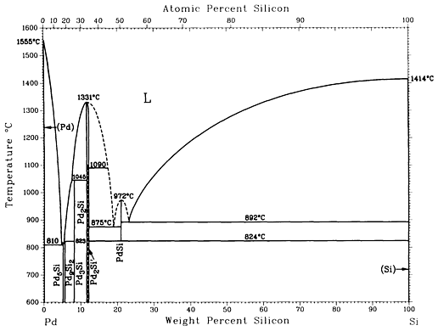
Figure A.1 – Palladium-Silicon Binary Phase Diagram

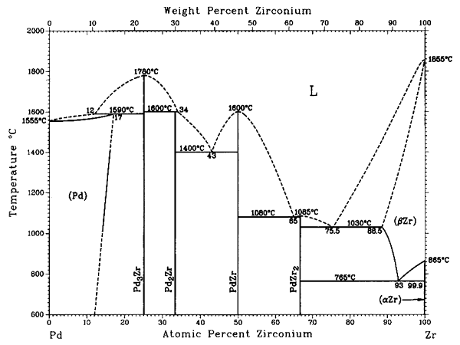
Figure A.2 – Palladium-Zirconium Binary Phase Diagram

References

[1] “Yeni Nesil Gaz Sogutmali Reaktorler,” Turkiye Atom Enerjisi Kurumu:
available online at <https://web.archive.org/web/20031211011036/http://www.taek.gov.tr/taek/td/html/gcr.html> (Dec. 12, 2004).

[2] M. LECOMTE, “Industrial aspects of revisited HTRs,” Nuclear Engineering and
Design, 209, 1-3, 233-241 (2001).

[3] T. FERREIRA, “South Africa’s nuclear programme,” Science in Africa: available
online at <https://web.archive.org/web/20040423174305/http://www.scienceinafrica.co.za/2003/june/pbmr.htm> (Dec. 12, 2004).

[4] L. TOPOR and O. J. KLEPPA, “Thermochemistry of the Systems Pd-Si and Pt-Si
at 1400 K,” Z. Metallkd., 77, 65-71 (1986).

[5] R. CASTANET and R. CHASTEL, “Thermodynamic Behaviour of Pd-Si, Pd-Ge
and Pt-Ge Molten Alloys,” Z. Metalldk., 78, 97-102 (1987).

[6] A. W. SEARCY and L. N. FINNIE, “Stability of Solic Phases in the Ternary Systems of Silicon and Carbon with Rhenium and the Six Platinum Metals,” Journal of the American Ceramic Society, 45, 6, 268-273 (1962).

[7] K. BHANUMURTHY and R. SCHMID-FETZER, “Experimental Study of Ternary Pd-Si-C Phase Equilibria and Pd/SiC Interface Reactions,” Z. Metallkd., 87, 244-253 (1996).

[8] S. STOLEN and T. MATSUI, “Thermodynamic analysis of the palladium-zirconium system,” Journal of Nuclear Materials, 186, 242-249 (1992).

[9] N. SELAHOUI and J. C. GACHON, “An Experimental Thermodynamic Study of the Pd-Zr System,” Laboratoire de Thermodynamique Metallurgique, 1108, 155-166 (1994).

[10] K. MINATO, et. al., “Fission product palladium-silicon carbide interaction in HTGR fuel particles,” Journal of Nuclear Materials, 172, 184-196

[11] A. NAOUMIDIS, R. BENZ, H. GRUBMEIER, “Behaviour of fission products in TRISO coated UO2 particles with stimulated high burnup,” High Temperatures – High Pressures, 14, 489-497 (1981).

[12] H. SUZUKI, T. ISEKI, T. IMANAKA, “Reactions between SiC and Pd or CeO2 at High Temperatures,” Journal of Nuclear Science and Technology, 14, 6, 438-442 (1977).

[13] K. MINATO et. al., “Fission product release from ZrC-coated fuel particles during postirradiation heating at 1600C,” Journal of Nuclear Materials, 224, 85-92 (1995).

MIT OpenCourseWare
http://ocw.mit.edu

22.THT Undergraduate Thesis Tutorial
Fall 2015

For information about citing these materials or our Terms of Use, visit: http://ocw.mit.edu/terms.

